# How to create a map for ZombieInvasion 2.0

You need:

* Tiled map editor (<http://www.mapeditor.org/download.html>)

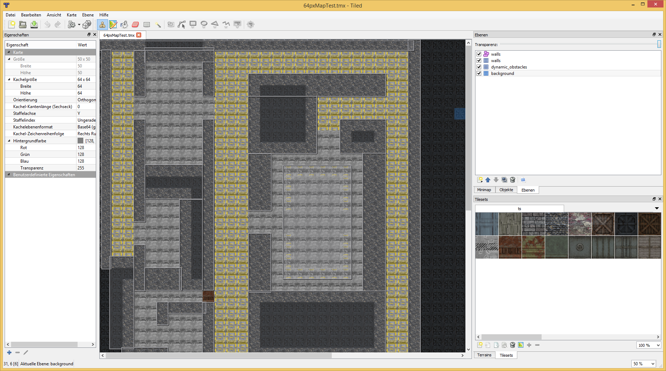

You have to create exactly 3 tile layer and 1 object layer.

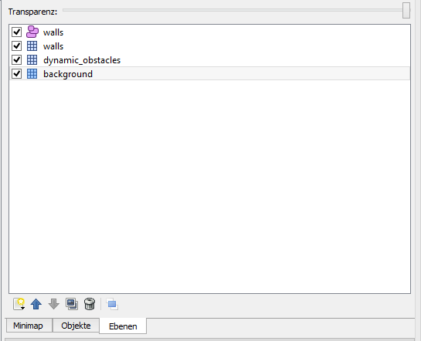walls(object layer): here you define the walls as „rectangle“ or „circle“ objects.

walls(tile layer): here you set the wall tiles.

dynamic_obstacles(tile layer): here you place tiles like locked doors and such.

background(tile layer): set all the background and walkable tiles.

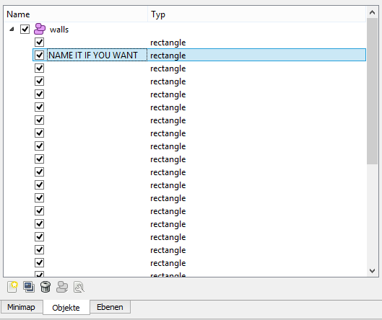In the object layer, you have to set the type of each object. (Rectangle/Circle)